TECHNICAL PROJECT REPORT

**AUTOMATIC WATERING POT GARDEN**

# Team Members / Inventors:

|  |  |  |  |  |  |
| --- | --- | --- | --- | --- | --- |
| **S.No.** | **Name** | **Department** | **Designation** | **Mobile** | **E-Mail** |
| 1. | Mohit | CSE (AI ML 2) | STUDENT | 7087735855 | Mohitmelwal21@gmaul.com |
| 2. | Ghanashyam | CSE (AI ML 2) | STUDENT | 6303815782 | Ghanashyam201@gmail.com |
| 3. | Siddharth | CSE (AI ML 2) | STUDENT | 9509583794 | Siddharthsao98@gmail.com |
| 4. | Jayant | CSE (AI ML 2) | STUDENT | 7527970192 | Jayantdeopa10@GMAIL.COM |
| 5. | Khushal Thakur | ECE | Mentor | 9646030764 | khushal.thakur@cumail.in |
| 6. | Anshul Sharma | ECE | Mentor | 9478697475 | anshulsharma.ece@cumail.in |
| 7. | Kiran Jot Singh | ECE | Mentor | 9463909689 | kiranjotsingh.ece@cumal.in |
| 8. | Divneet Singh Kapoor | ECE | Mentor | 9878422653 | divneet.ece@cumail.in |

Section – 1 (IPR Related)

# Brief Abstract (500 words):

In this system, soil moisture sensor senses the moisture level of the soil. If soil will get dry then sensor senses low moisture level and automatically switches on the water pump to supply water to the plant. As plant get sufficient water and soil get wet then sensor senses enough moisture in soil. After which the water pump will automatically get stopped.

we have used a self-made water pump in this system using a motor. I made DC motor based water pump using diode, transistor and registers,relay, combined circuit which operates DC motor according to the Arduino code.

We have made a demo garden which will work same as the regular one. In the garden we made water storage with pump, small plants and flowers are been planted in small box, a circuit is made consisting of arduino, relay, wires, bread board, soil moisture sensor, resistor. The whole system will work mainly on the basis of the program feed in arduino. The soil moisture sensor will sense the moisture level and if the level is low than required the pump will start automatically and garden will be watered.

# Existing state-of-the-art and Drawbacks in existing state-of-the-art

|  |  |  |
| --- | --- | --- |
| **S. No.** | **Existing state of art** | **Drawbacks in existing state of art** |
| 1 | Measures soil moisture and waters plants if necessary. It contain a alarm system also which notifies the user when water level is low . | Owner needs to take care of water level of tank and also electricity is always needed to run the motor always. |
| 2 |  |  |

# Novel/Additional modifications that you can propose to improve upon drawbacks

* We can fit a water sensor in tank to detect the water level, which alarms when the water level is low and automatically fills the tank from the connected tap.
* We can attach a inverter or generator to fix the electricity problem.

# Advantages

* Now the person will not have to worry about the low water level or will not have to fill the tank his efforts will be saved.
* Plant can be watered in case of no electricity.

# Block Diagram

Watering to soil/ Plants

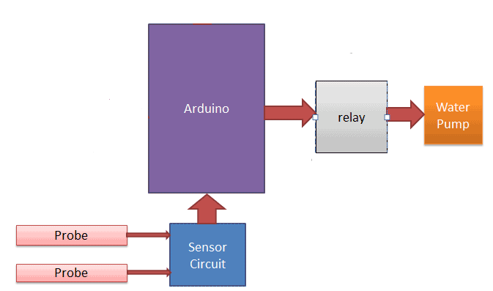

Power Supply

Materials

|  |  |  |  |
| --- | --- | --- | --- |
| S.NO | ITEM | QUANTITY | PRICE (RS) |
| 1 | ARDUINO | 1 | 370 |
| 2 | RELAY | 1 | 70 |
| 3 | RESISTOR | 2 | 0.50*2 |
| 4 | DC MOTOR | 1 | 250 |
| 5 | SOIL MOISTURE SENSOR | 1 | 190 |
| 6 | MALE FEMALE JUMPER WIRE | 10 | 1*10 |
| 7 | BREAD BOARD | 1 | 70 |
| 8 | POT&WATER CONTAINER | 2 | 75*2 |
| 9 |  |  |  |

# **Circuit Diagram**

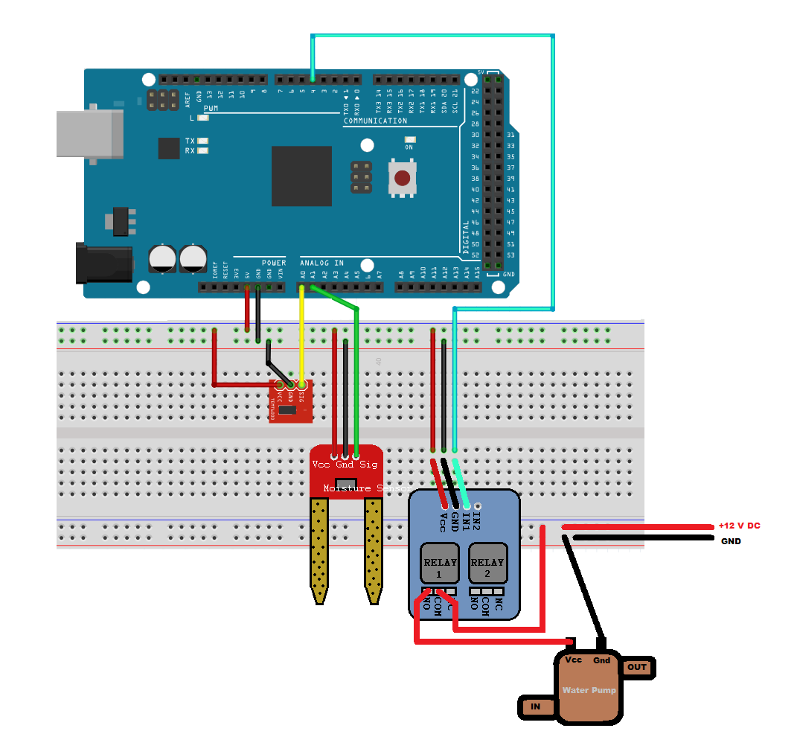

# **Steps of Circuit Completion**

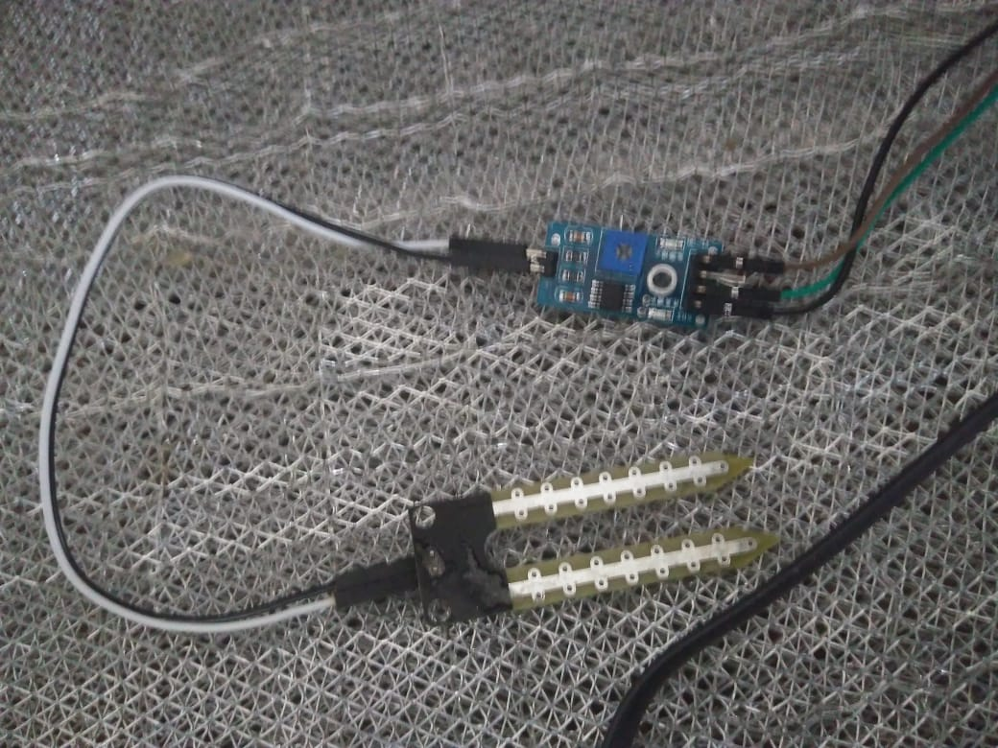

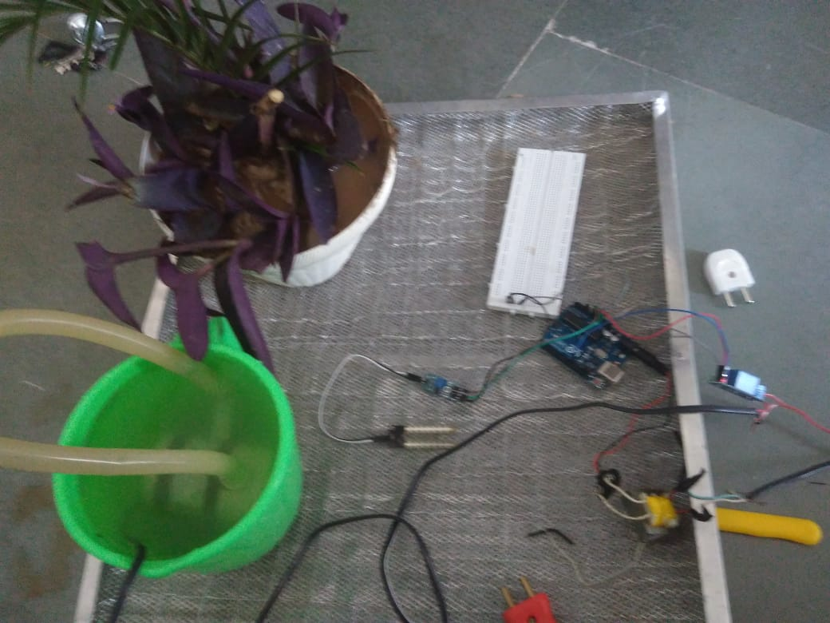

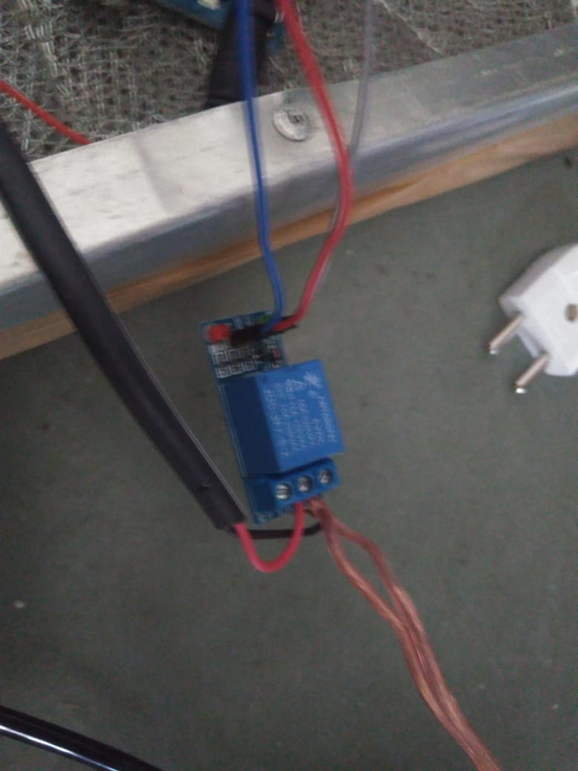

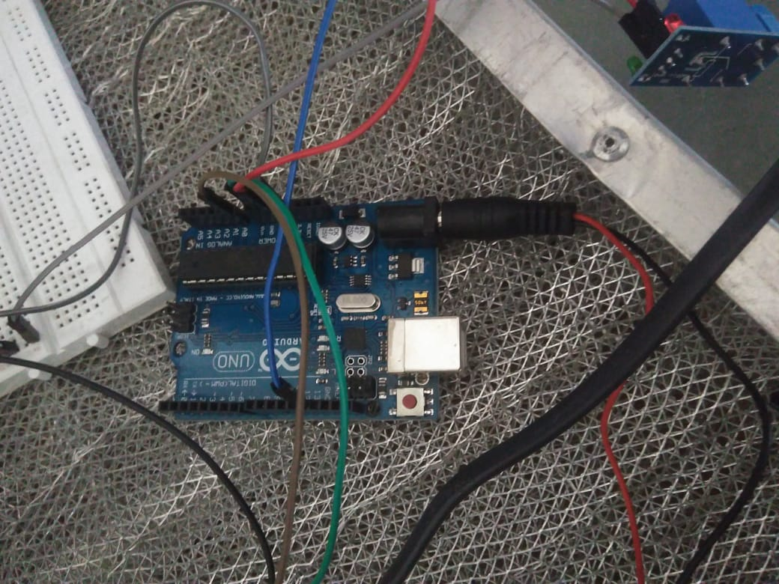

# Program Code

(*Link of your Github project*)